**Ideally the AFS schedule starts on a Friday**

|  |  |  |  |  |  |
| --- | --- | --- | --- | --- | --- |
|  | **Mon** | **Tues** | **Wed** | **Thur** | **Fri** |
| **Week 1** | **Freeze tissue sometime this week or before** |  |  |  | **Day 1: UA infiltration** |
| **Week 2** | **Day 2: Lowicryl infilitration** | **Day 3: UV polymerization** |  |  | **Day 4: Clean up and store tissue** |
| **Week 3** | **Day 5: Turn off AFS/ finish clean up** |  |  |  |  |

#### Friday, Day 1: UA infiltration over the weekend

**Preparation**:

* 1.5% uranyl acetate (plenty for four chambers): UA dissolve very slowly, so you may want to prepare it few hours in advance or the day before and store in 4C with light protection. Depending on how many chambers you need, you can prepare less UA to reduce the waste.
  + 0.75g in 50 ml anhydrous acetone (*weigh in hood*)
  + make in 50 mL conical, wrap in Al foil
* Filter 1.5% uranyl acetate using 0.2 µm 25 mm syringe filter and 60mL syringe
* If necessary, clean all the metal containers and AFS accessories with acetone in sonicator ~1 min.

**PROCEEDURE**

1. Fill AFS machine with liquid nitrogen. Set the AFS program to cool down to -90°C.
2. Fill as many AFS chambers as you will need with Reichert capsules, 8 sections per chamber, place chambers in AFS, and fill filtered UA into each chamber from the middle hole of the chamber. Cool chambers in the AFS machine for about 2 hours.

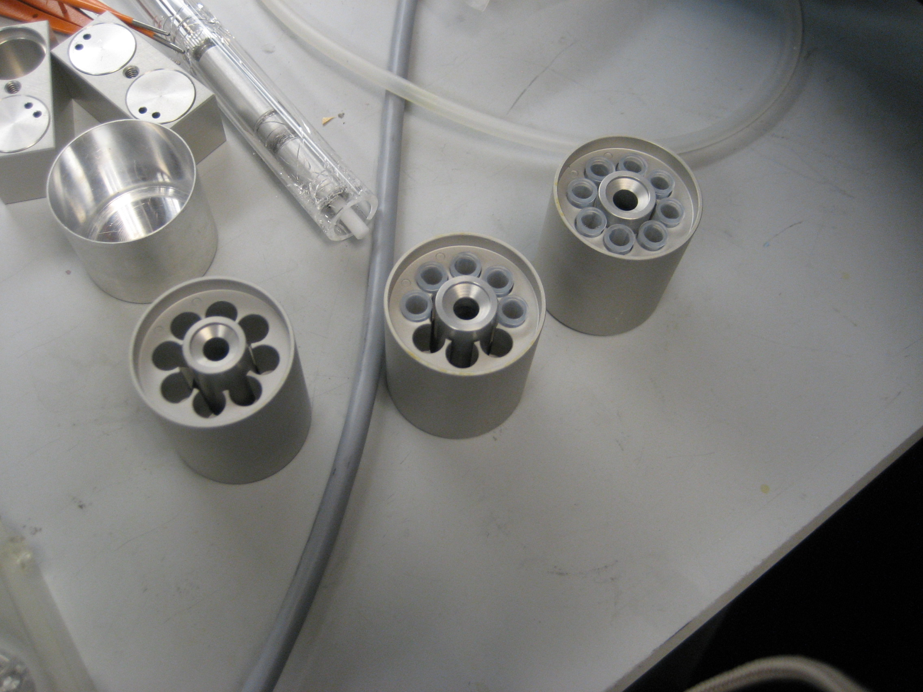.

1. Use the program that will leave specimens at –90°C for 30 hours, then raise temperature in 4°C increments per hour to –45°C
2. You must wait 2-3 days before going on to Day 2 of AFS.

**Monday, Day 2: Lowicryl infiltration**

1. Pre-cool anhydrous acetone for at least 20 mins in buffer chambers. Wash samples with anhydrous acetone, 3 times, 15 minutes per wash. Use plastic pipettes to transfer solutions. Note: if you reuse the pipettes, leave them in the AFS chamber so you do not introduce condensation

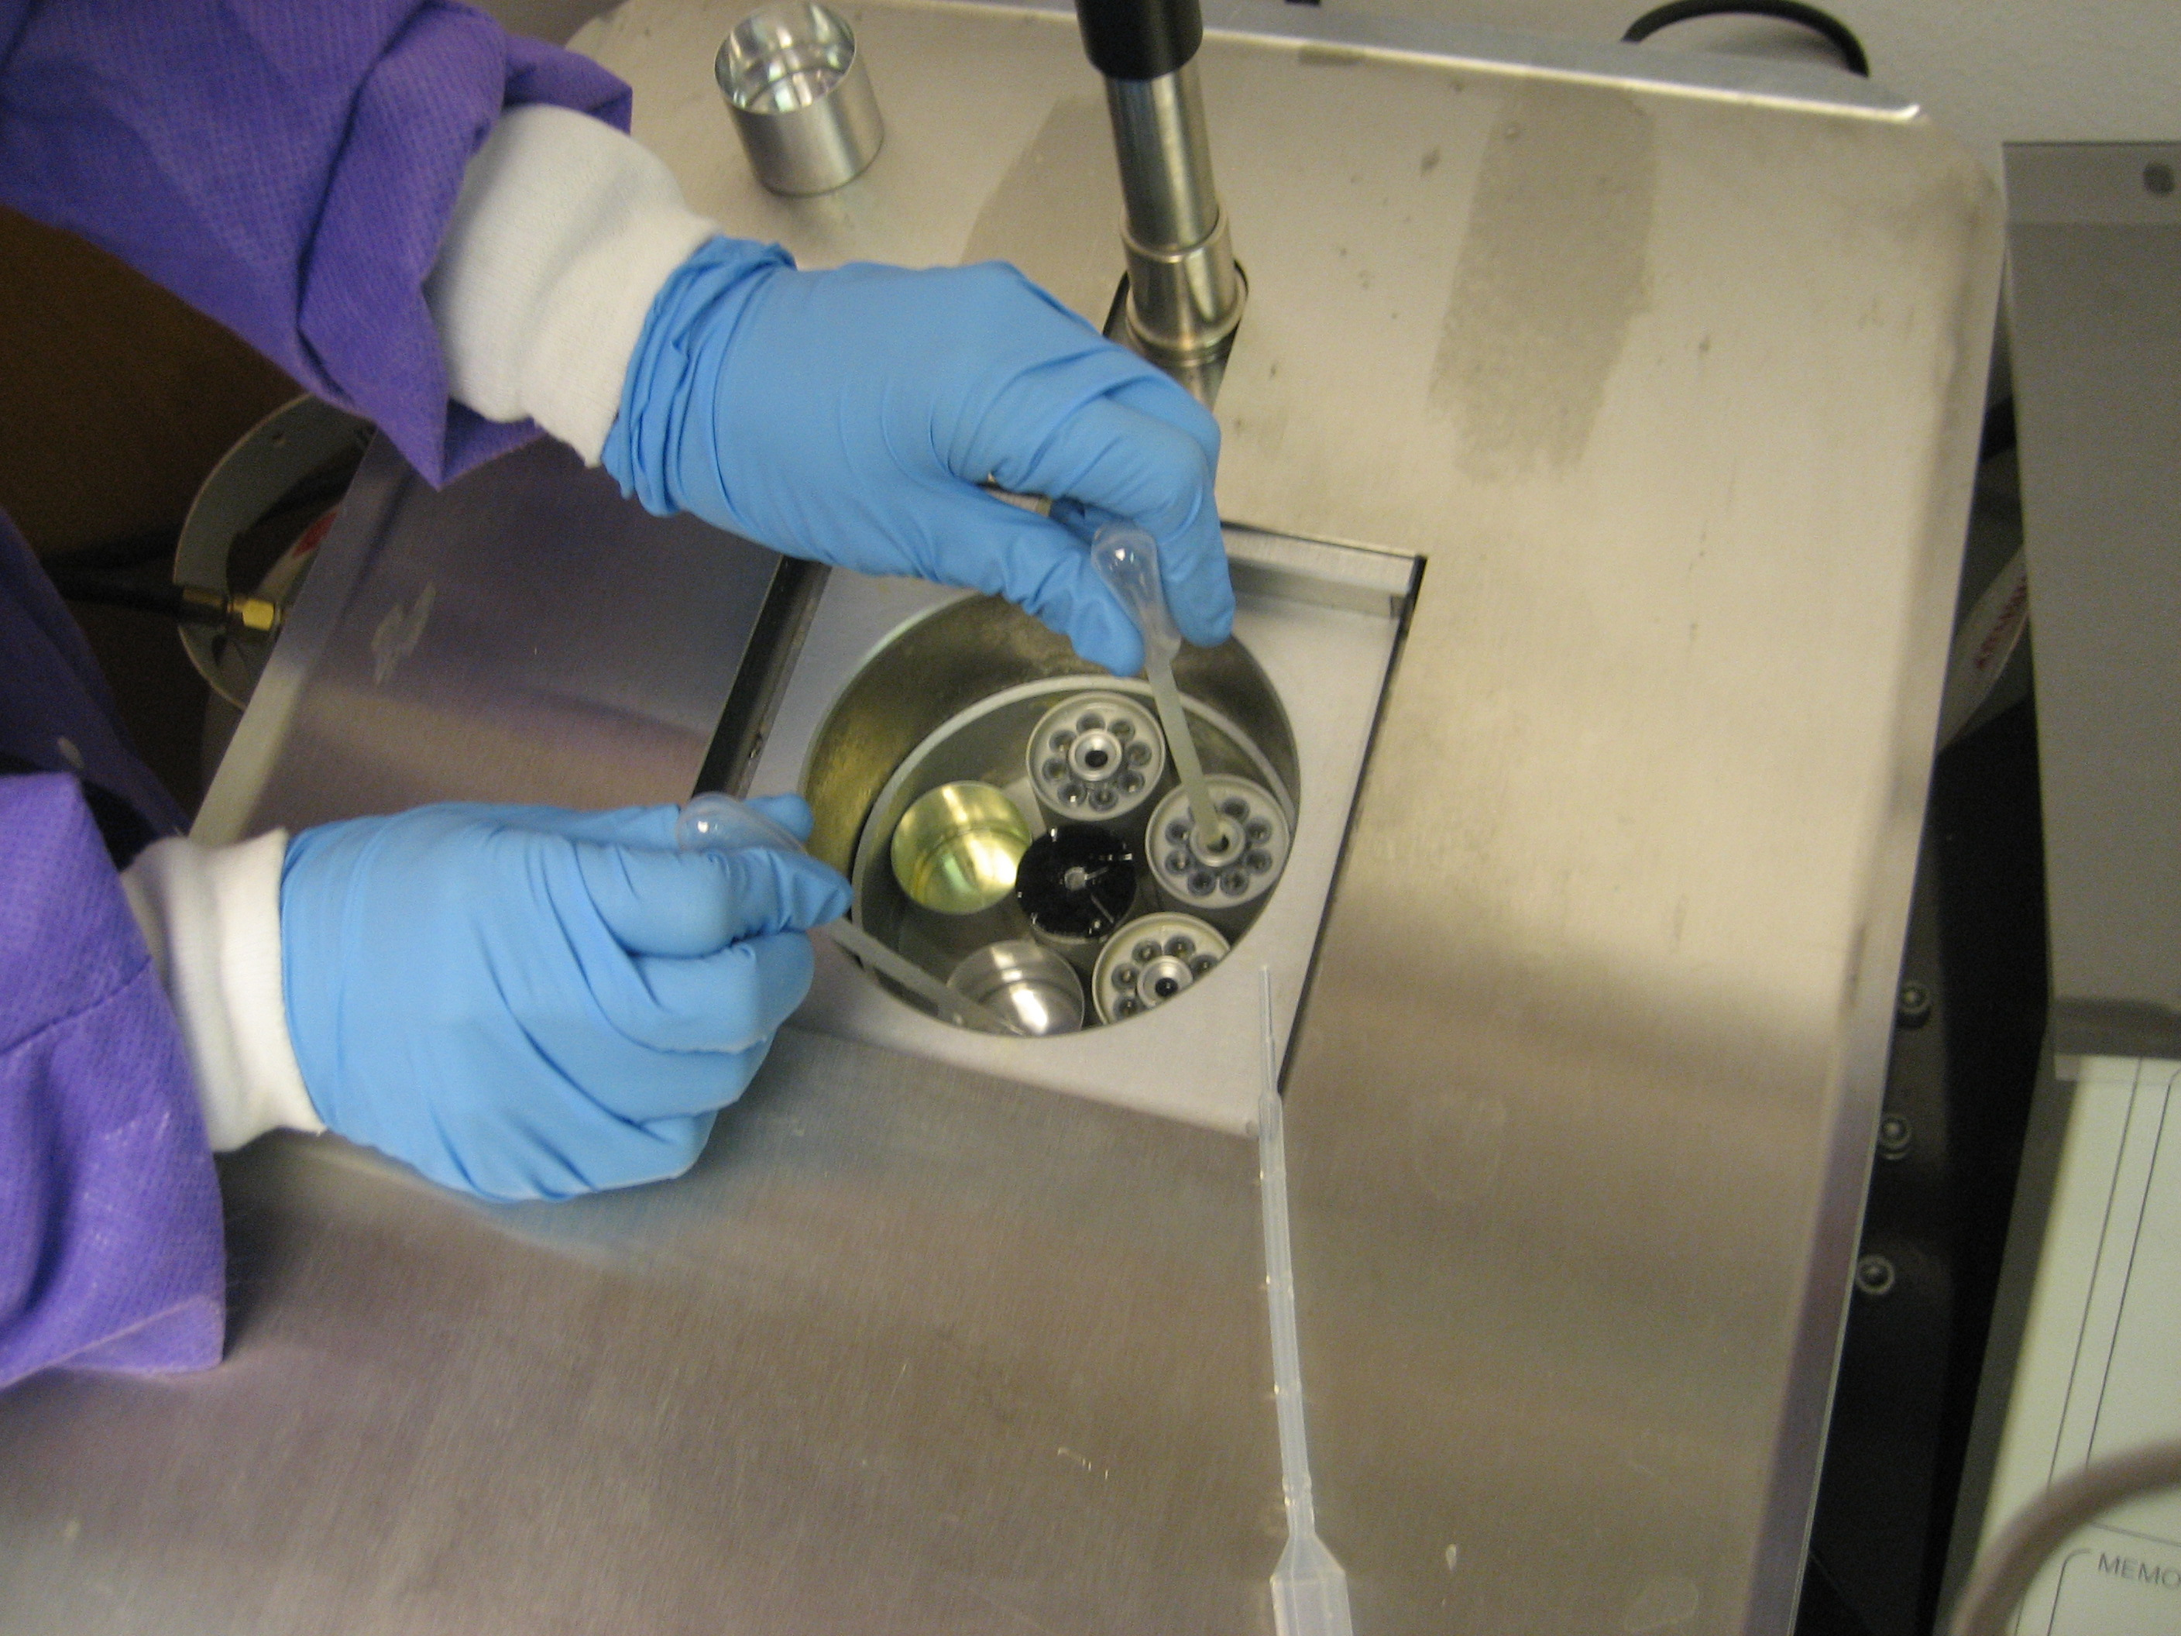

1. Prepare resin as follows during the 1st 15 min wash or during initial cooling. Wear goggles and gloves.

Use the **Lowicry HM20 Embedding Kit**

(Electron Microscopy Sciences- Cat#14340)

|  |  |  |  |  |
| --- | --- | --- | --- | --- |
| # of Cylinders: | 1 | 2 | 3 | 4 |
| Crosslinker D | 4.47 g | 7.45 g | 10.43 g | 13.41 g |
| Monomer E | 25.53 g | 42.55 g | 59.57 g | 76.59 g |
| Initiator C | 0.15 g | 0.25 g | 0.35 g | 0.45 g |

**Be extremely careful! Monomer E is smelly but Initiator C is a neurotoxin!**

-Add each chemical or solution to a plastic beaker on the scale- tare between each reading. Use a plastic pipette cut at an angle as a spoon.

-After adding Monomer E, use a transfer pipette with bulb cut off to ***bubble nitrogen gas*** into the beaker for two minutes to remove oxygen and mix the liquid.

-Then add Initiator C. Again bubble nitrogen gas for two minutes.

-Leave covered solution in hood. Clean the scale well with methanol or acetone after use!

1. To do infiltration with Lowicryl HM20 resin at -45oC, change buffers every two hours as follows. Be sure to pre-cool the buffers for at least twenty minutes each time before changing (You can stack them all in at the same time if space allows).
   1. *Lowicryl/acetone 1:1* 2 hours
2. *Lowicryl/acetone 2:1* 2 hours
3. *Pure Lowicryl* 2 hours
4. *Pure Lowicryl* Over Night

_______________________________________________________________________

#### Tuesday, Day 3: UV-Polymerization

1. Prepare labels for each block using font size 6. Insert the rolled label for each block into Reichert capsules.
2. Add more LN2 to the AFS machine.
3. Bubble lowicryl HM20 w/ N2 gas to get rid of O2 in hood. Pre-cool for 20 mins.
4. Change solution to the pre-cooled Lowicryl, and leave for 1 hour.
5. Place small gel capsules into the G chamber (Fig. 8) and cool in AFS. Fill capsules with Lowicryl.
6. Place holders (central pole to rest spider cover upon) in buffer containers, fill 1/8 with acetone (Fig. 9). Pre-cool for at least 20mins.

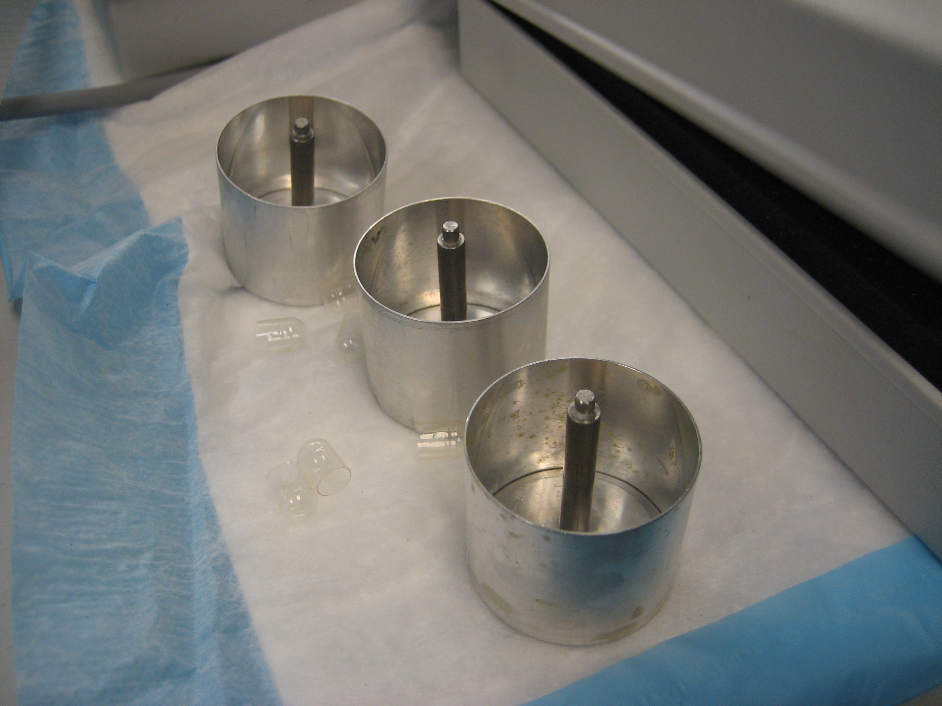

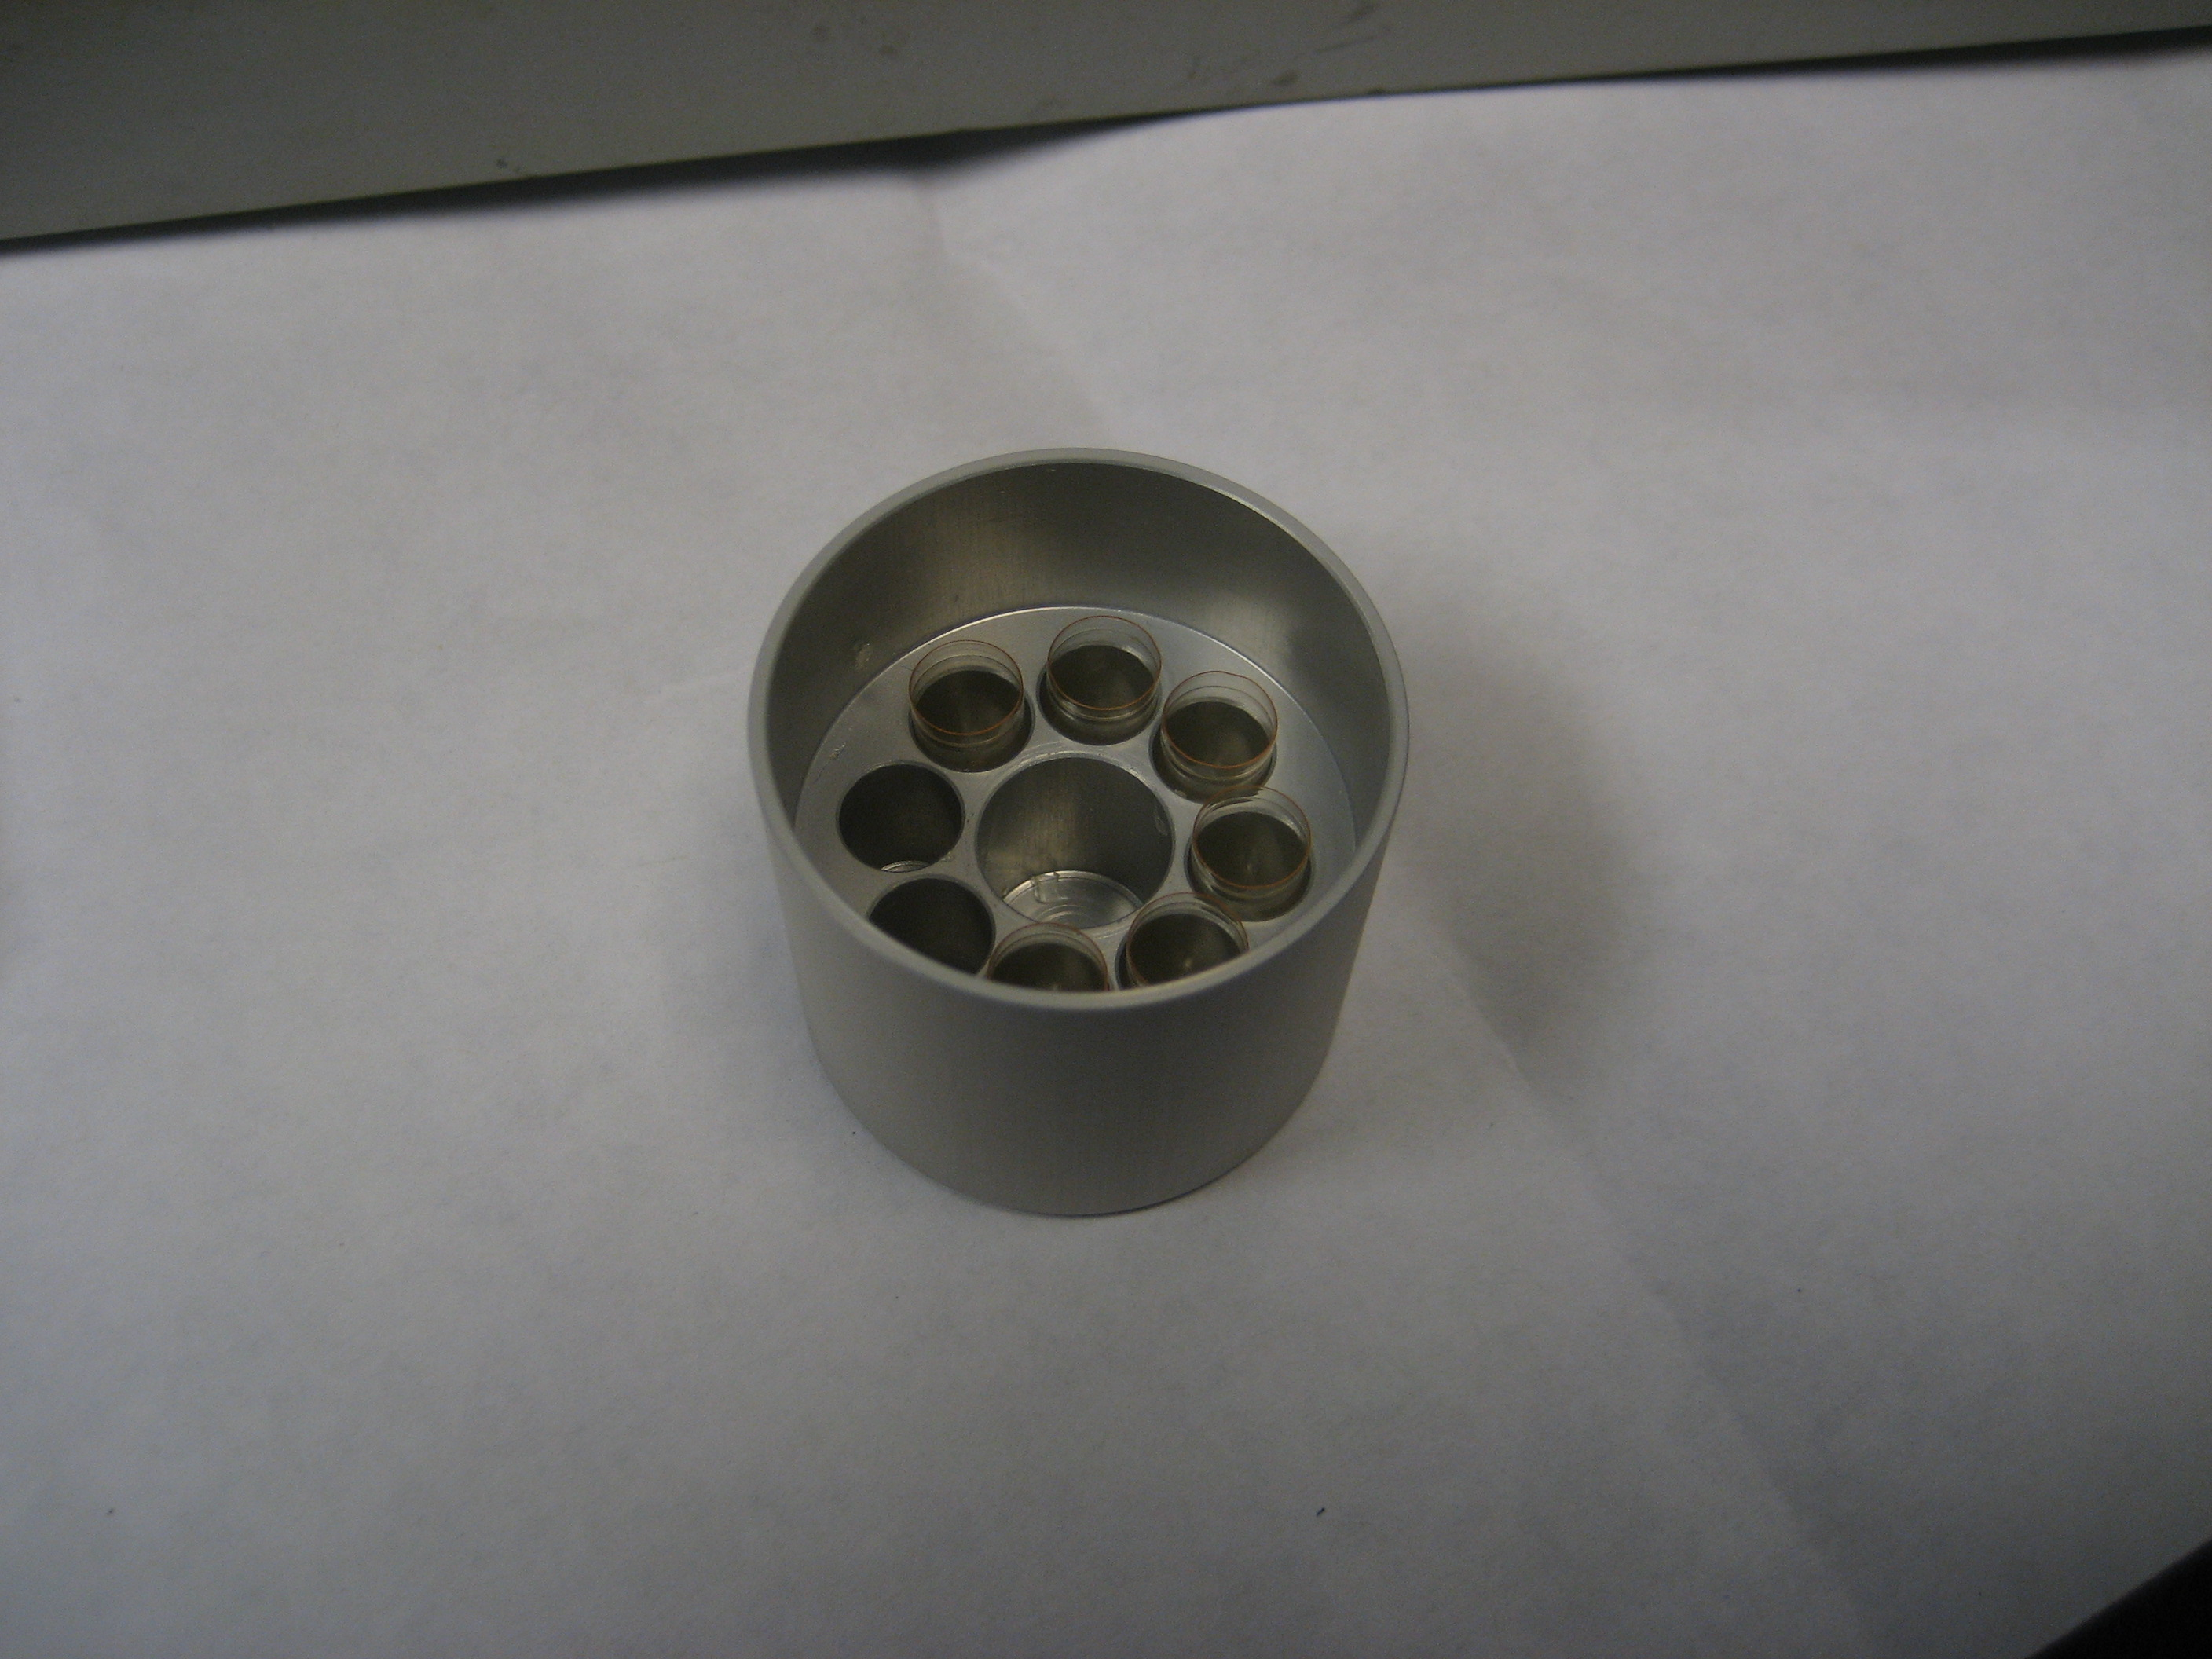

G Chamber Buffer containers with holders

1. Move the Reichert capsules to gelatin capsules using the “spider cover”. Push hard for tight fit.

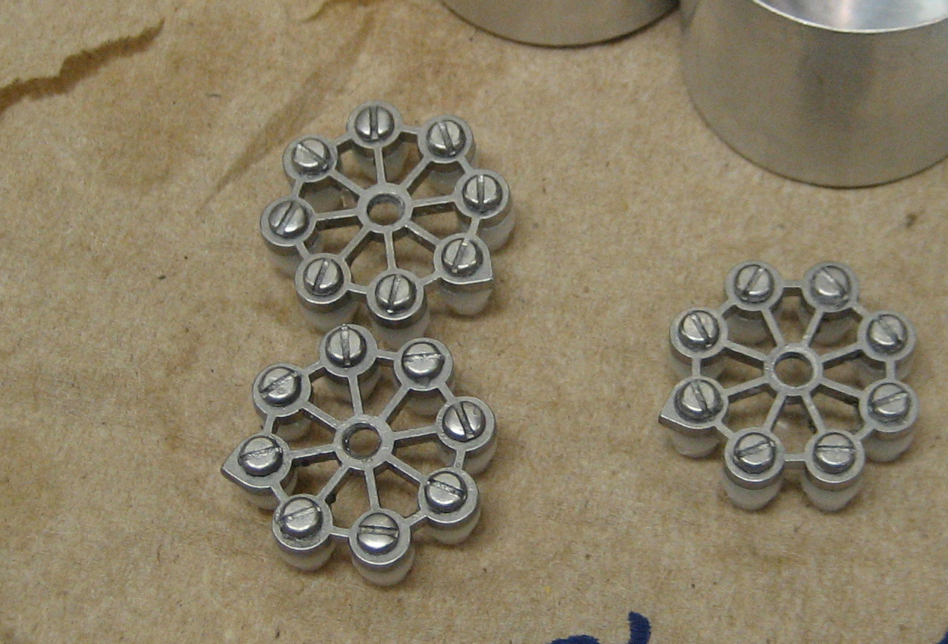

Spider Cover

1. Transfer capsules to acetone container (with central pole to rest spider cover upon).Acetone acts as a temperature sink during UV-light polymerization.
2. Put UV light in place, plug in
3. Select program, 24hr at -45oC. Increase temp to 0oC (increase 4°C /hr), 35hr at 0°C.

____________________________________________________________________

#### Friday, Day 4: Clean Up

Take out the specimen and check if the tissue is there. Clean everything with acetone.

1. Set AFS Machine to burn out program (60C) for 3 days to get rid of excess liquid nitrogen.

**_______________________________________________________________________**

#### Monday, Day 5: Clean Up, Cont.

**Turn off machine and ensure everything is clean, put back in its place and that there is enough of each reagent for next run.**